Event Readiness Planner

A Mini Project Report Submitted in Partial Fulfilment of the Requirements for the Award of the Degree of
MASTER OF COMPUTER APPLICATIONS (MCA)
Submitted by
GURUPRASAD, LAXMI PUGATI, MOHAMMAD HUSSAIN
Register Number:

Under the Guidance of Mr. RAJESH KUMAR

Department of Computer Applications
ACHARYA INSTITUTE OF GRADUATE STUDIES
Affiliated to Bengaluru City University BENGALURU – 2026

DECLARATION
I hereby declare that this project titled 'Event Readiness Planner' is a Bonafide work carried out by me during the academic year 2026 under the guidance of Mr. Rajesh Kumar. This work has not been submitted elsewhere for any other degree.

ACKNOWLEDGEMENT
I sincerely thank my project guide Mr. Rajesh Kumar for his continuous support and guidance. I extend my gratitude to the faculty and management of Acharya Institute of Graduate Studies for providing the facilities required for the successful completion of this project

INDEX
- Declaration
- Acknowledgement
- Introduction
- Scope of the Project
- Feasibility of the Project
- System Design
- Existing Application
- Proposed Application
- Conceptual ER Diagram
- Logical ER Diagram
- Source Code
- Screenshots
- Conclusion

Introduction :
in today’s fast-paced environment, effective event planning requires proper organization, coordination, and tracking of multiple activities. events such as seminars, conferences, workshops, weddings, and corporate meetings involve numerous tasks, deadlines, and vendor arrangements. managing these activities manually using notebooks or spreadsheets often leads to miscommunication, duplication of work, data inconsistency, and lack of proper monitoring.
to address these issues, a computerized system is essential to maintain structured records and ensure smooth coordination. the event readiness planner is a console-based java application designed to automate and simplify the management of events, tasks, and vendor information. the system provides a centralized platform for storing and retrieving event-related data efficiently.
the application is developed using java programming language and integrates with a mysql relational database using jdbc (java database connectivity). it follows the dao (data access object) design pattern, which separates business logic from database operations. this layered approach improves maintainability, scalability, and modularity of the application.
the system allows users to:
- add and manage event details such as event name, date, and location.
- assign and track tasks related to specific events.
- store and manage vendor information including service type and contact details.
- perform crud (create, read, delete) operations through a structured menu-driven console interface.
the database design follows proper relational modeling techniques with primary and foreign key constraints to maintain referential integrity. the relationship between event and task entities is modeled as a one-to-many relationship, ensuring structured task management for each event.
this project not only provides a practical solution for small-scale event management but also demonstrates important software engineering principles such as:
- object-oriented programming (oop)
- database normalization
- er diagram modeling
- layered system architecture
- exception handling
- jdbc workflow implementation
the event readiness planner serves as an academic demonstration of integrating programming concepts with database systems to build a reliable and maintainable software solution. it lays a strong foundation for future enhancements such as graphical user interface (gui), web-based deployment, role-based authentication, and reporting modules.
in conclusion, this project bridges theoretical knowledge and practical implementation by developing a structured, database-driven application that improves efficiency and organization in event planning activities.

Scope of the project
The scope of the event readiness planner project defines the range of functionalities, operational boundaries, and future expansion possibilities of the proposed system. The project focuses on developing a console-based java application that manages events, tasks, and vendor information using a mysql database and dao design pattern.

1. Functional scope
The system is designed to perform the following core operations:

1.1 event management
- Create and store event details such as event name, date, and location.
- View the list of all events stored in the database.
- Delete event records when required.
- Maintain structured and organized event data.

1.2 task management
- Assign multiple tasks to a specific event.
- Track task descriptions and their status (e.g., pending or completed).
- Maintain a one-to-many relationship between event and task.
- Ensure data integrity using foreign key constraints.

1.3 vendor management
- Store vendor information such as vendor name, service type, and contact details.
- Maintain vendor records for future event assignments.
- Organize service provider data systematically.

1.4 database operations
- Perform crud operations (create, read, delete).
- Maintain relational database structure.
- Ensure primary and foreign key constraints are enforced.

2. Technical scope
The project is developed using:
- Java for application development.
- Mysql as the backend database.
- Jdbc for database connectivity.
- Dao design pattern for separation of concerns.
- Layered architecture for modular development.
The system runs as a console-based application and does not require high-end hardware or specialized infrastructure.

3. Academic scope
This project demonstrates the practical implementation of:
- Object-oriented programming (oop)
- Er diagram modeling
- Database normalization techniques
- Jdbc connectivity
- Software development life cycle (sdlc)
- Exception handling in java
- Structured and modular coding practices
It serves as an academic model for understanding how database-integrated applications are developed using industry-standard design patterns.

4. Operational scope
The system is suitable for:
- Small-scale event planners
- Academic institutions
- Training and learning purposes
- Demonstration of database-driven applications
It is designed for single-user operation through a simple menu-driven interface.

5. Future scope
The system can be extended in the future to include:
- Gui-based desktop application (javafx/swing)
- Web-based application using spring boot
- User authentication and role-based access
- Report generation and analytics
- Vendor-event assignment (many-to-many relationship)
- Notification and reminder system

6. Limitations
- Console-based interface only
- No multi-user support
- Limited security features
- Basic crud operations only
- No graphical reporting module

Summary
The scope of the event readiness planner project is focused on developing a structured, maintainable, and database-driven application that efficiently manages event planning activities while demonstrating key software engineering concepts.

Feasibility of the Project
A feasibility study is conducted to evaluate whether the proposed system is practical and achievable within the given constraints. The feasibility of the Event Readiness Planner project is analyzed under the following categories:

1. Technical Feasibility
Technical feasibility examines whether the required technology and technical resources are available to develop and implement the system.
The Event Readiness Planner is developed using:
- Java Programming Language
- Mysql Database
- JDBC (Java Database Connectivity)
- DAO Design Pattern
- Standard IDE tools (Eclipse / intellij)
These technologies are:
- Widely available and open-source
- Well-documented and stable
- Suitable for academic and small-scale applications
The system does not require advanced hardware or special infrastructure. A basic computer with standard specifications is sufficient to run the application.
Conclusion: The project is technically feasible as it uses standard and accessible technologies.

2. Economic Feasibility
Economic feasibility evaluates the cost required to develop and operate the system.
The project uses free and open-source software tools such as:
- Java (Open-source)
- Mysql Community Edition
- Free IDE platforms
There are no licensing costs or additional hardware investments required. The only cost involved is the development time and effort.
Conclusion: The project is economically feasible as it involves minimal to no financial cost.

3. Operational Feasibility
Operational feasibility determines whether the system can be effectively used in a real-world environment.
The application provides:
- A simple menu-driven console interface
- Easy navigation using switch-case options
- Clear instructions for user input
Users do not require specialized training to operate the system. The system ensures data integrity through primary and foreign key constraints.
Conclusion: The system is operationally feasible because it is easy to use and maintain.

4. Schedule Feasibility
Schedule feasibility determines whether the project can be completed within the allotted academic timeframe.
The development process includes:
- Requirement analysis
- System design and ER diagram creation
- Database implementation
- Coding using DAO pattern
- Testing and debugging
- Documentation preparation
The project can be completed within a semester duration (6–8 weeks).
Conclusion: The project is feasible within the given academic timeline.

5. Legal Feasibility
The project does not violate any legal requirements. It uses open-source technologies and does not handle sensitive personal data. Therefore, it complies with standard software usage policies.
Conclusion: The project is legally feasible.

Overall Feasibility Conclusion
After evaluating technical, economic, operational, schedule, and legal aspects, it can be concluded that the Event Readiness Planner project is fully feasible. The system can be successfully developed and implemented within the available resources, timeframe, and academic constraints.

System Design
System design is the process of defining the architecture, components, modules, interfaces, and data structures of a system to satisfy specified requirements. The Event Readiness Planner is designed using a structured and modular approach to ensure maintainability, scalability, and clarity.

1. Overall Architecture
The application follows a Layered Architecture combined with the DAO (Data Access Object) Design Pattern.

1.1 Architectural Layers
The system consists of the following layers:

1️⃣ Presentation Layer
- Console-based user interface
- Menu-driven interaction
- Implemented in the main class using switch-case statements
- Handles user input and displays output

2️⃣ Business / Service Logic Layer (Basic Logic in Main)
- Processes user requests
- Validates input
- Calls DAO methods to perform operations

3️⃣ DAO Layer
- Contains DAO interfaces and DAO implementation classes
- Responsible for performing database operations
- Encapsulates SQL queries
- Provides abstraction between application logic and database

4️⃣ Utility Layer
- Contains connectionfactory class
- Establishes database connection using JDBC
- Centralized connection management

5️⃣ Model Layer (Bean Classes)
- Represents database tables as Java classes
- Contains private variables and getter/setter methods
- Example: Event, Task, Vendor

2. Design Pattern Used

2.1 DAO (Data Access Object) Pattern
The DAO pattern is used to separate:
- Database access logic
- Business logic

Advantages:
- Improves maintainability
- Makes code reusable
- Reduces dependency between layers
- Easy to modify database without changing application logic
Example:
- Eventdao (Interface)
- Eventdaoimpl (Implementation class)

3. Database Design
The system uses a Relational Database (mysql).

3.1 Tables

EVENT Table
- Event_id (Primary Key)
- Name
- Date
- Location

TASK Table
- Task_id (Primary Key)
- Event_id (Foreign Key)
- Description
- Status

VENDOR Table
- Vendor_id (Primary Key)
- Name
- Service_type
- Contact

3.2 Relationships
- One Event can have multiple Tasks (1:N relationship)
- TASK contains foreign key referencing EVENT
- Vendor is currently independent but extendable

4. ER Design
The system is modeled using an Entity-Relationship (ER) Diagram.

Entities:
- EVENT
- TASK
- VENDOR

Relationship:
- EVENT (1) → TASK (N)
Primary and Foreign keys ensure referential integrity.

5. Module Design
The project is divided into modules:

Module 1: Event Management
- Add Event
- View Events
- Delete Event

Module 2: Task Management
- Add Task
- View Tasks
- Update Task Status

Module 3: Vendor Management
- Add Vendor
- View Vendors
Each module interacts with its corresponding DAO class.

6. Data Flow Design

Step-by-Step Flow:
- User selects option from console menu.
- Main class receives input.
- Calls respective DAO method.
- DAO interacts with database using JDBC.
- Database returns result.
- Output displayed on console.

7. Input and Output Design

Input Design
- Structured console prompts
- Date input in yyyy-mm-dd format
- Integer-based menu options

Output Design
- Tabular display of event data
- Clear confirmation messages
- Error messages for invalid input

8. Security and Integrity Design
- Primary key constraints
- Foreign key constraints
- Exception handling using try-catch blocks
- Controlled database connection via connectionfactory

9. Normalization
The database design follows normalization principles:
- 1NF: Atomic values
- 2NF: No partial dependency
- 3NF: No transitive dependency
This ensures minimal redundancy and maximum consistency.

10. Future Design Enhancements
The system design supports extension to:
- GUI-based interface
- Web-based architecture (MVC)
- REST apis
- Multi-user authentication
- Reporting dashboard

Summary
The system design of the Event Readiness Planner follows a layered architecture using DAO design pattern to ensure modularity, maintainability, and scalability. The relational database structure, proper normalization, and ER modeling provide a strong foundation for reliable event management operations.

Existing Application (Existing System)
Before the development of the Event Readiness Planner, event management activities were generally handled using manual methods or basic digital tools. These traditional systems lack proper organization, automation, and structured database management, which leads to inefficiencies in handling event-related tasks and vendor coordination.

1. Manual Record-Keeping System
In many small organizations and institutions, events are managed manually using notebooks, printed schedules, or physical files. All event details, task assignments, and vendor information are recorded on paper.

Drawbacks:
- High risk of data loss or damage.
- Time-consuming data entry and retrieval.
- No backup or recovery mechanism.
- Difficulty in tracking task completion.
- Increased chances of human errors.
Manual systems are not suitable when managing multiple events simultaneously.

2. Spreadsheet-Based System
Some organizations use spreadsheet software such as Microsoft Excel to maintain event data. Although spreadsheets provide digital storage, they do not offer relational database capabilities.

Limitations:
- No enforcement of primary and foreign key constraints.
- Data duplication and redundancy.
- Lack of structured relationships between events and tasks.
- No automated validation.
- Difficult to manage large datasets.
- No modular architecture or separation of logic.
Spreadsheets are limited in handling complex event-task relationships efficiently.

3. Generic Event Management Software
There are various web-based event management applications available in the market. However, these systems often:
- Require paid subscriptions.
- Need constant internet access.
- Include complex features not required for small-scale usage.
- Lack customization for academic purposes.
For small institutions or academic projects, these solutions may not be cost-effective or necessary.

Problems Identified in the Existing System
The existing systems suffer from the following problems:
- Lack of centralized database management.
- No structured relationship between event and task data.
- Limited automation and tracking capabilities.
- Poor data integrity and validation.
- No separation between user interface and database logic.
- Difficult maintenance and scalability issues.

Need for the Proposed System
Due to the limitations of the existing system, there is a need for a structured, database-driven application that:
- Automates event and task management.
- Maintains proper relational database design.
- Ensures data integrity using primary and foreign keys.
- Follows modular architecture using DAO design pattern.
- Provides efficient data storage and retrieval.

Summary
The existing applications for event management rely primarily on manual processes or basic spreadsheet tools, which lack efficiency, scalability, and structured database management. These limitations highlight the necessity for a well-designed system like the Event Readiness Planner, which provides an organized, automated, and reliable solution for managing event-related information.

Proposed Application (Proposed System)
The proposed system, Event Readiness Planner, is a console-based Java application developed to automate and streamline the management of events, tasks, and vendor information. The system is designed to overcome the limitations of manual and spreadsheet-based methods by providing a structured, database-driven solution.
The application integrates Java programming with mysql database connectivity using JDBC and follows the DAO (Data Access Object) design pattern to ensure modularity and maintainability.

1. Overview of the Proposed System
The Event Readiness Planner provides a centralized platform to:
- Store event details such as event name, date, and location.
- Assign and track tasks associated with each event.
- Maintain vendor information including service type and contact details.
- Perform CRUD operations (Create, Read, Delete) efficiently.
The system ensures proper data organization using relational database design principles.

2. Key Features of the Proposed System

2.1 Event Management
- Add new events.
- View all existing events.
- Delete events when required.
- Store event data in a structured database.

2.2 Task Management
- Assign multiple tasks to a specific event.
- Track task status (Pending / Completed).
- Maintain one-to-many relationship between Event and Task.
- Ensure referential integrity using foreign key constraints.

2.3 Vendor Management
- Add vendor details.
- View vendor information.
- Maintain structured vendor database.

2.4 Menu-Driven Interface
- Simple console-based navigation.
- Switch-case implementation for user options.
- Clear and user-friendly prompts.

3. System Architecture
The proposed system follows a layered architecture:
- Presentation Layer – Console interface for user interaction.
- DAO Layer – Handles database operations.
- Model Layer – Bean classes representing database tables.
- Utility Layer – connectionfactory for managing database connection.
This architecture ensures separation of concerns and improves maintainability.

4. Advantages of the Proposed System
- Automated event management.
- Reduced manual errors.
- Structured relational database.
- Data integrity using primary and foreign keys.
- Modular and scalable architecture.
- Easy to maintain and extend.
- Cost-effective solution.
- Suitable for academic and small-scale applications.

5. Improvement Over Existing System
Existing System | Proposed System
Manual or spreadsheet-based | Database-driven system
No structured relationships | Proper relational modeling
High data redundancy | Normalized database design
Limited automation | Automated CRUD operations
No modular architecture | DAO-based layered architecture

6. Future Enhancements
The proposed system can be extended to:
- GUI-based desktop application
- Web-based application using Spring Boot
- User authentication and role management
- Reporting and analytics module
- Vendor-event assignment (Many-to-Many relationship)
- Notification and reminder system

Summary
The proposed Event Readiness Planner system provides a reliable, structured, and scalable solution for managing event-related activities. By integrating Java, JDBC, mysql, and DAO design pattern, the system ensures efficient data handling, improved organization, and maintainable software architecture. It successfully addresses the limitations of existing systems while providing a strong foundation for future enhancements.

Conceptual ER Diagram
This diagram shows the high-level entities and their relationships

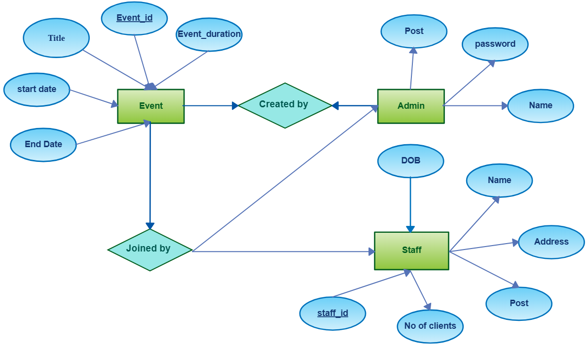

Logical ER Diagram (With Attributes)

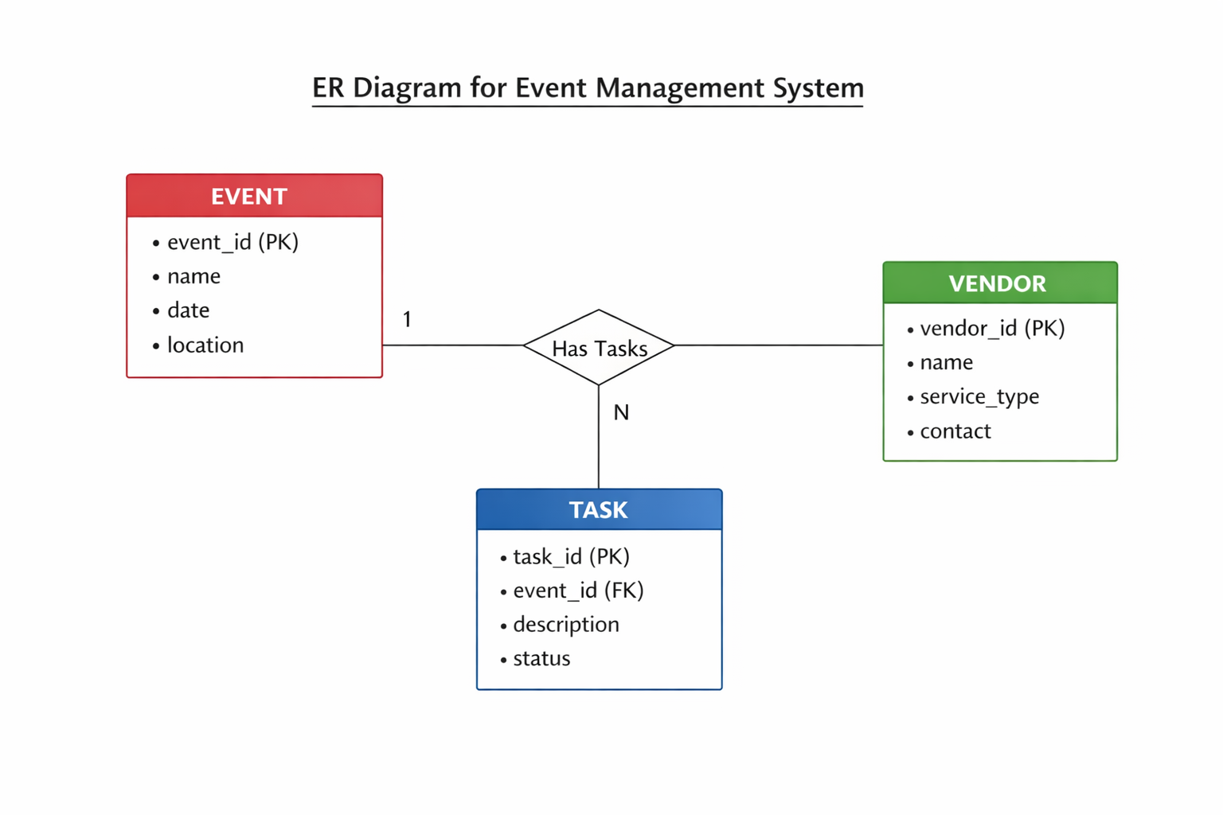
This diagram includes primary keys, foreign keys, and attributes

Coding and your application screenshots….
Class of ConnectionFactory :
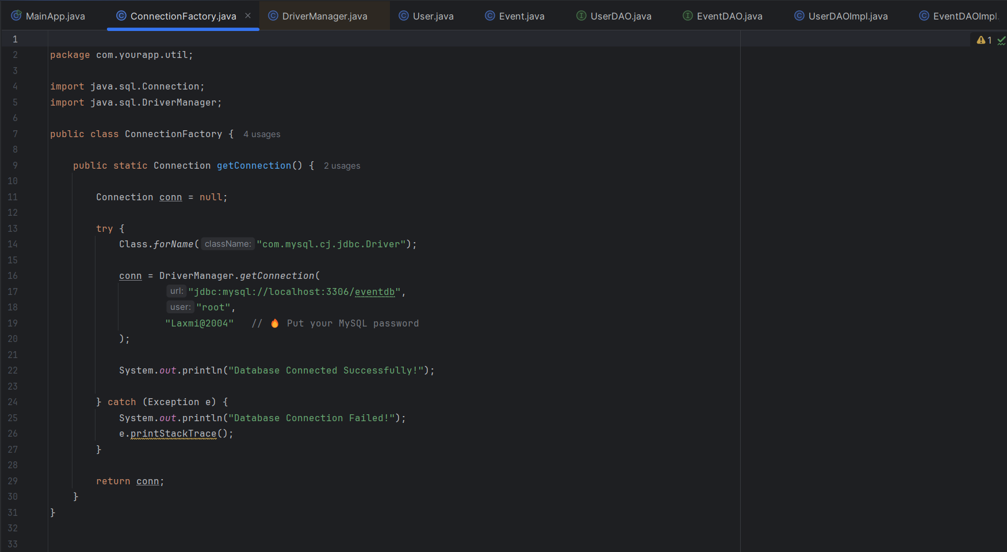
Class of user :
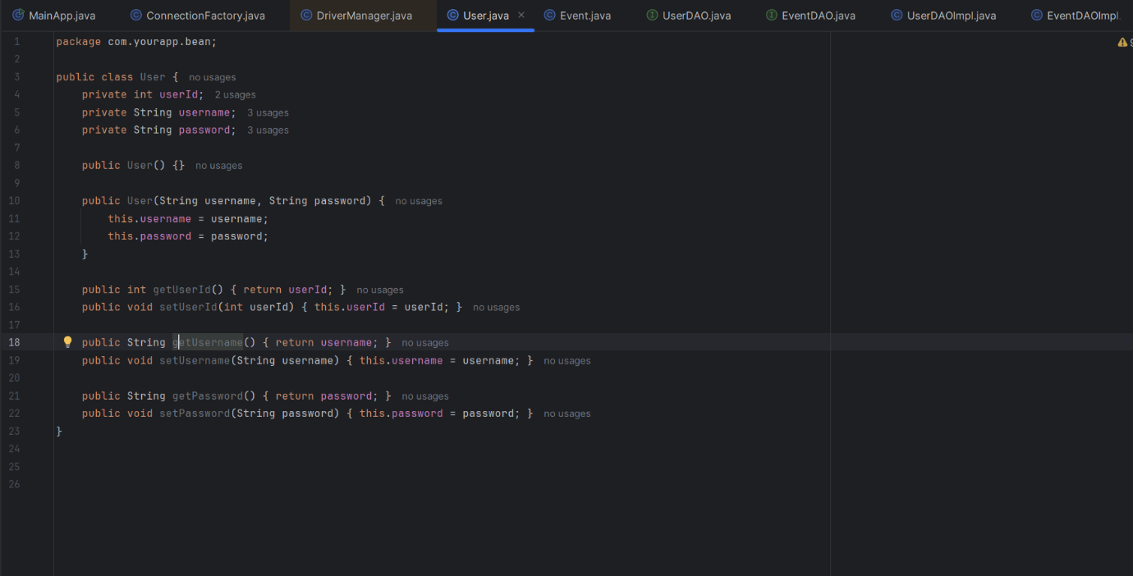

Class of userDAO :
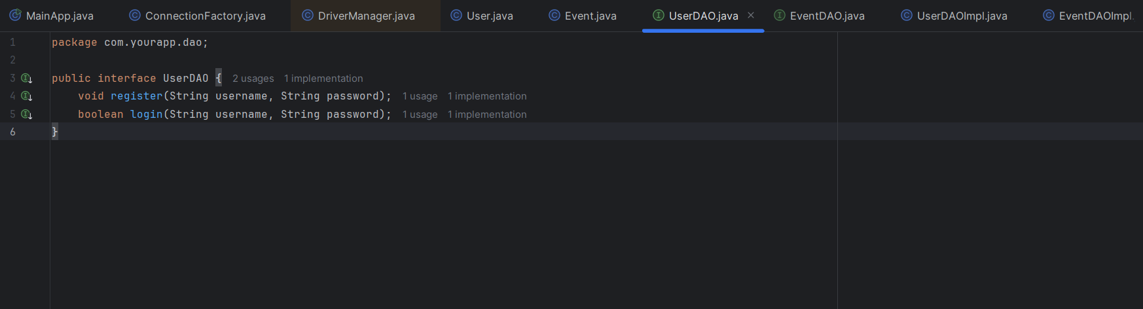
Class of event :
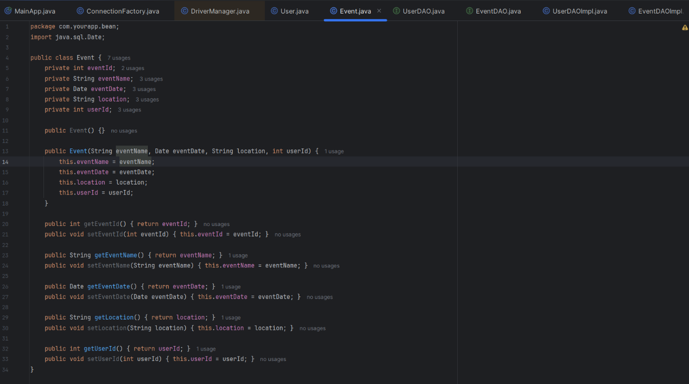

Class of eventDAO :
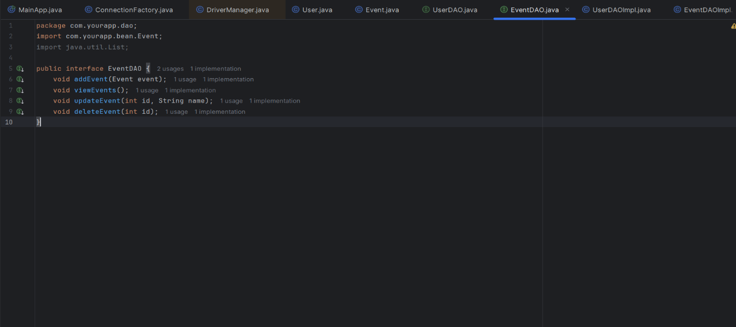
Class of UserDAOImpl :
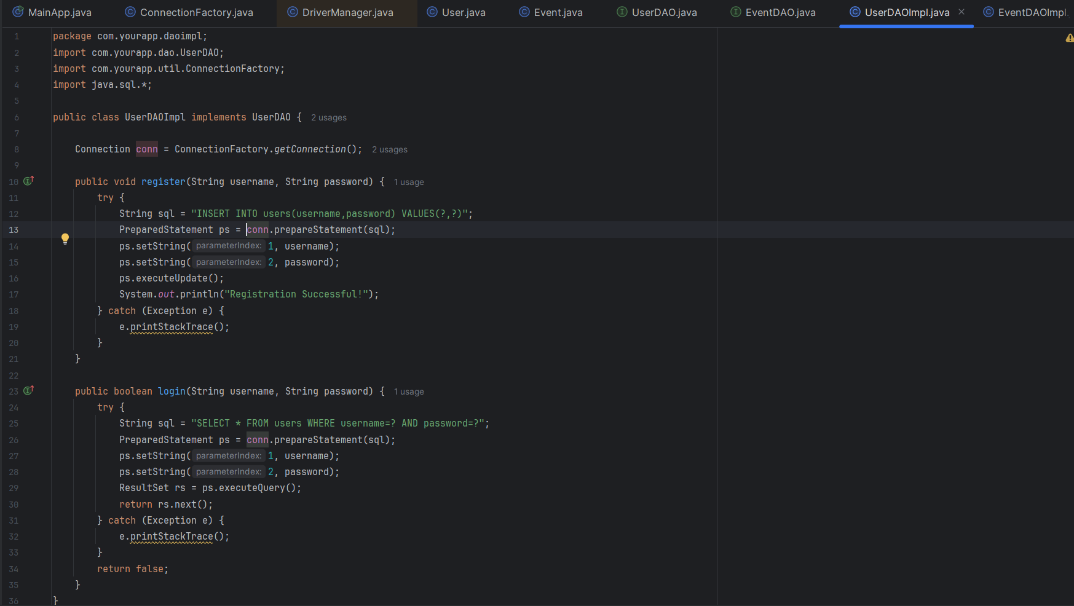

Output Screenshots :
Registration :
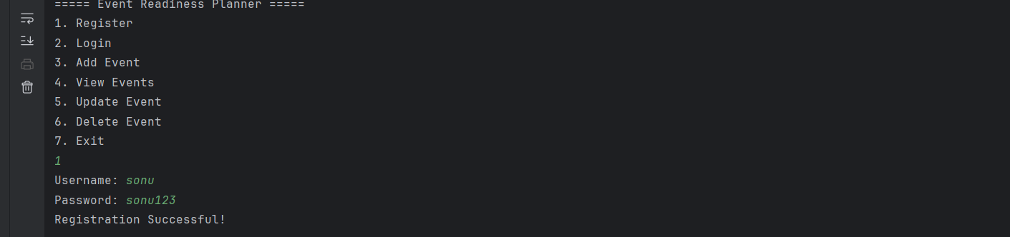
Login :
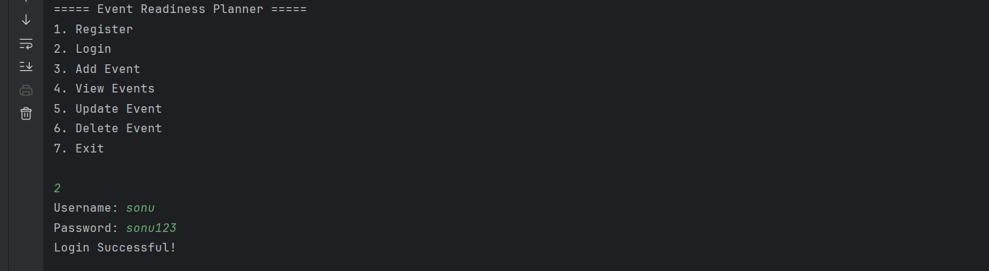
Adding event :
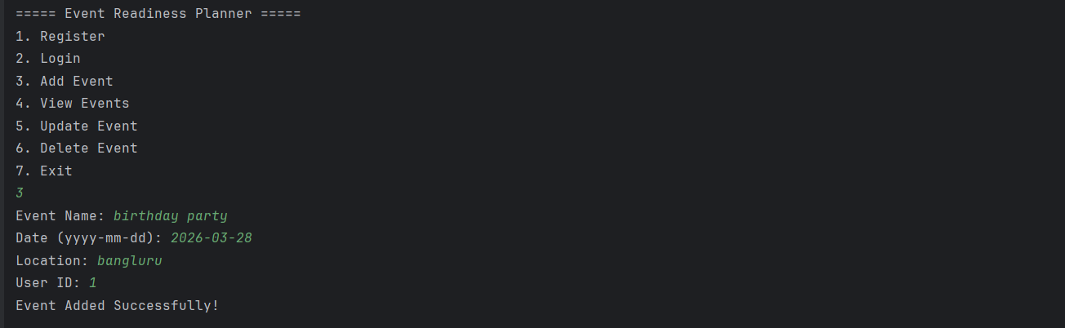
View event :
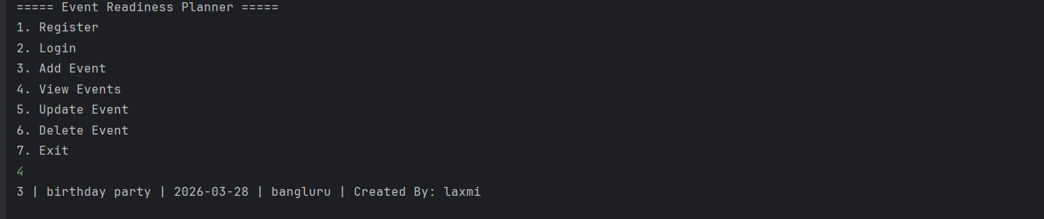
Updating event :
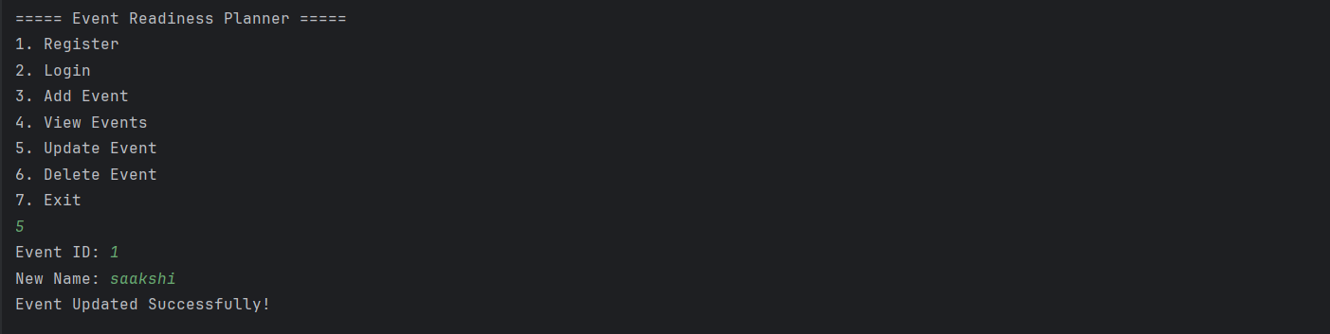
Deleting event :
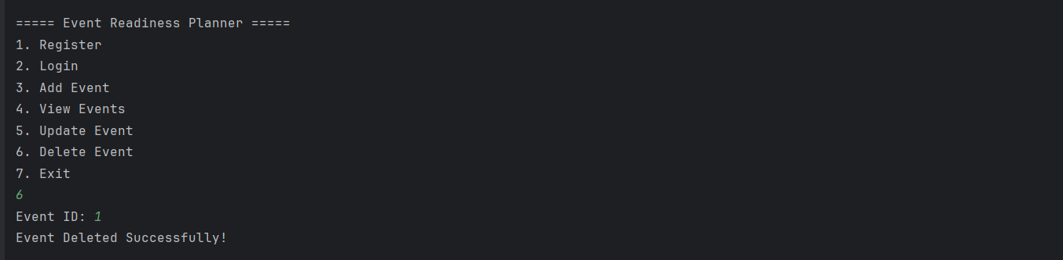
Exit :
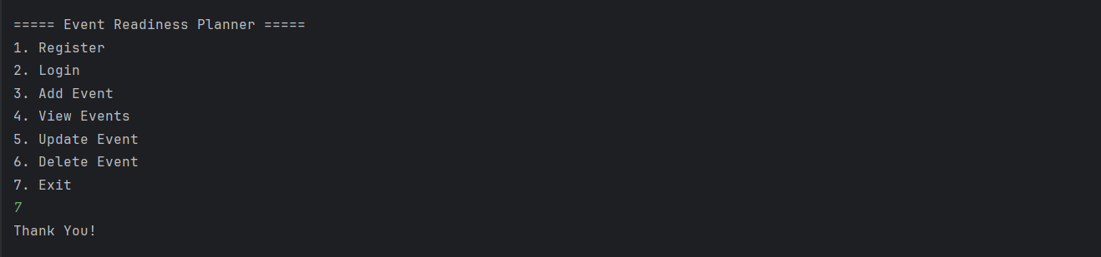

Conclusion
The Event Readiness Planner project successfully demonstrates the development of a structured, database-driven console application using Java and MySQL. The system was designed to automate and simplify the management of events, tasks, and vendor information, replacing manual and unstructured methods of event planning.
By implementing the DAO (Data Access Object) design pattern, the application ensures proper separation between business logic and database operations, resulting in a modular, maintainable, and scalable architecture. The use of JDBC connectivity enables efficient interaction with the MySQL database while maintaining data integrity through primary and foreign key constraints.
The project effectively applies important software engineering concepts such as Object-Oriented Programming (OOP), layered architecture, ER diagram modeling, and database normalization. The one-to-many relationship between Event and Task entities ensures organized task tracking and structured data management.
Overall, the Event Readiness Planner provides a reliable and efficient solution for small-scale event management. It serves as a strong academic implementation of database-integrated application development and lays a foundation for future enhancements such as graphical interfaces, web-based deployment, authentication mechanisms, and reporting modules.

REFERENCES
1. Oracle Java Documentation.
2. MySQL Official Documentation.
3. Database System Concepts
4. JDBC API Documentation.

